BORDER PORTFOLIO NOTES

“Chain link can’t contain culture”
“El muro no para mi cultura”
“Fences can’t keep out culture”

History and border formation
In what ways has the shared history of the borderlands both united and separated the people and cultures on both sides?

Culture
What makes the border culture unique?

Shared biculturalism

Oscar J. Martínez, Ph.D.
University of Arizona

Many borderlanders live and function in several different worlds: the world of their national culture, the world of the border environment, the world of their ethnic group if they are members of a minority population, and the world of the foreign culture on the other side of the boundary.

In truth [the border] is a world apart-a third very unsovereign nation, not wholly American and not quite Mexican either, with its own customs, mores, values, and even its own language, Spanglish. Family ties, religious roots, and economic interdependence knit the border region in both countries together to the point that [U.S. border cities] have more in common with their sister towns in Mexico than they do with most of the United States.

Based on the level of transboundary contact, the border population may be divided into two general types: (l) national borderlanders
and (2) transnational borderlanders.

National borderlanders are people who, while subject to foreign economic and cultural influences, have minimal or superficial contact with the opposite side of the border owing to their indifference to their next-door neighbors or their unwillingness or inability to function in any
substantive way in another society.

Transnational borderlanders, on the other hand, are individuals who maintain significant ties with the neighboring nation; they seek to overcome obstacles that impede such contact and take advantage of every opportunity to visit, shop, work, study, or even live on the "other side."

- Border Persona Typologies
1,2, 3, 4
- Telenovelas: Mexico's hottest import
ABCNEWS.com video via Yahoo! News - Mon, Oct 08, 2007

Shared history
- Timeline of the border
- prehistoric Indians Yaqui Indians 1200 AD
- the railroad
- the Battle of Ambos Nogales 8/28/1918
- the Maquillia industry
- the produce industry

Separation in History
- “Operation Wet Back”
- Battle of Ambos Nogales
- The U.S. Mexican War/ Gadsden Purchase
- The separation of the wall and laws

- The wall
- San Diego wall
Passport laws
- Check points
- Immigration law

What are some cultural differences?
- Small cultural things
- La mordida
- Credit/economy
- House and car ownership
- Attitude towards taxes government/police
- Influence of the church

- 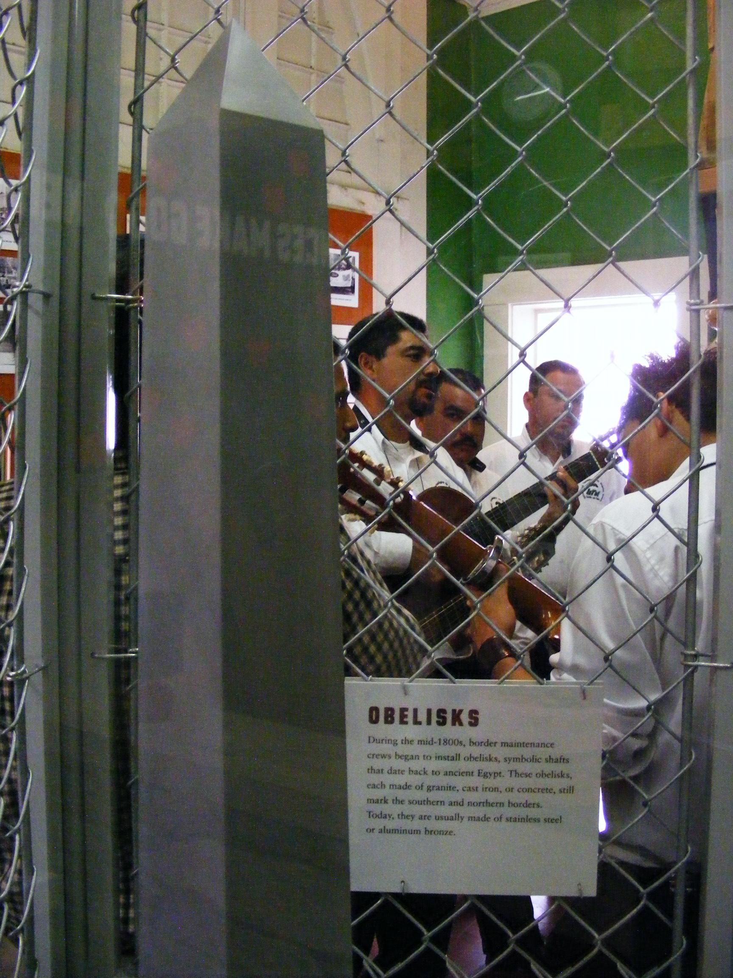

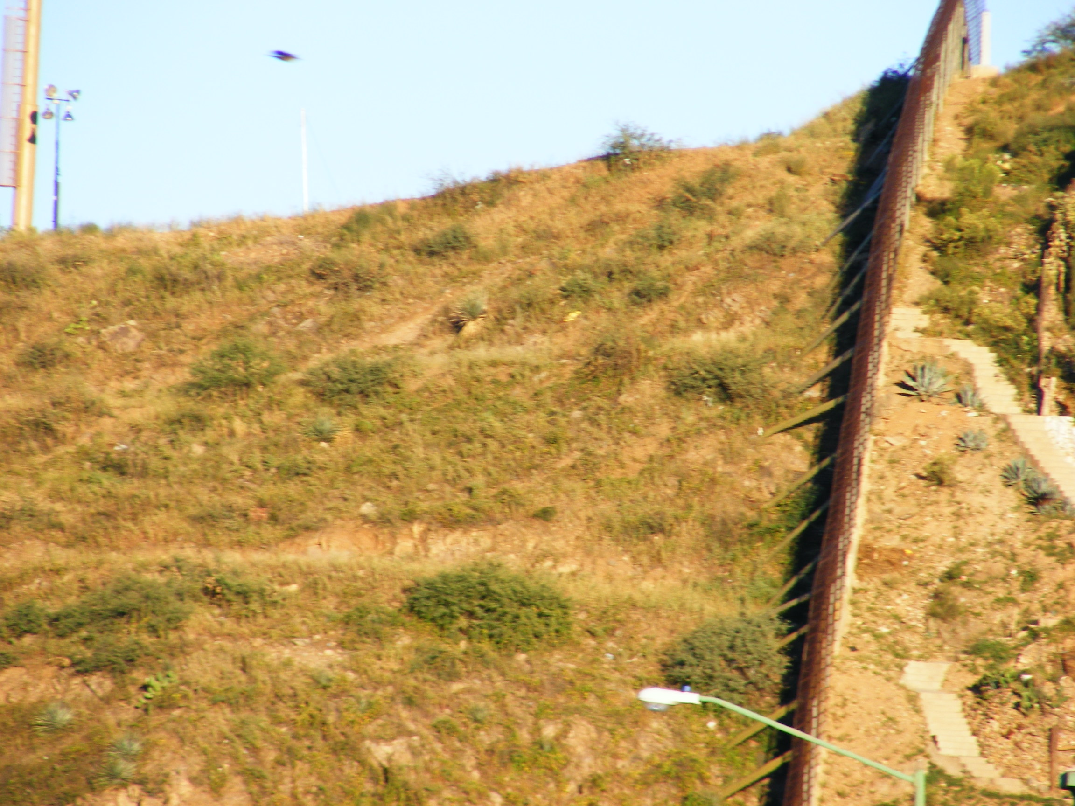

- Minutemen' plan to patrol Arizona border
Volunteers want to stop illegal immigrants entering U.S.
- Go to this link for many articles on Mexican culture and government
- Border Security video
- The border fence – Talk of the Nation
- 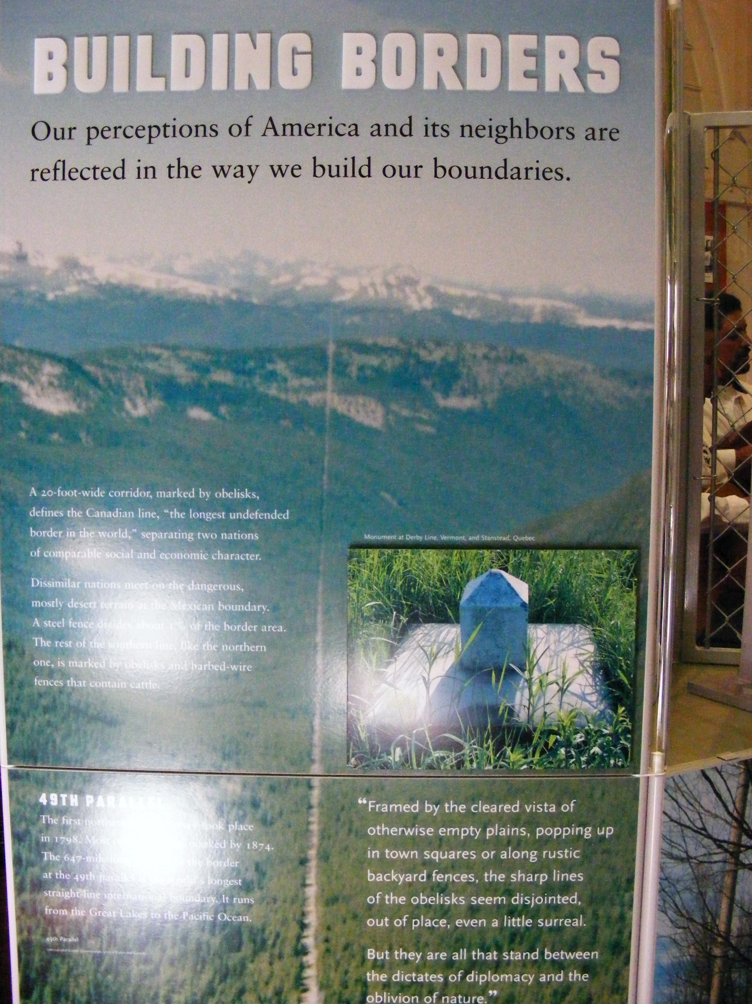

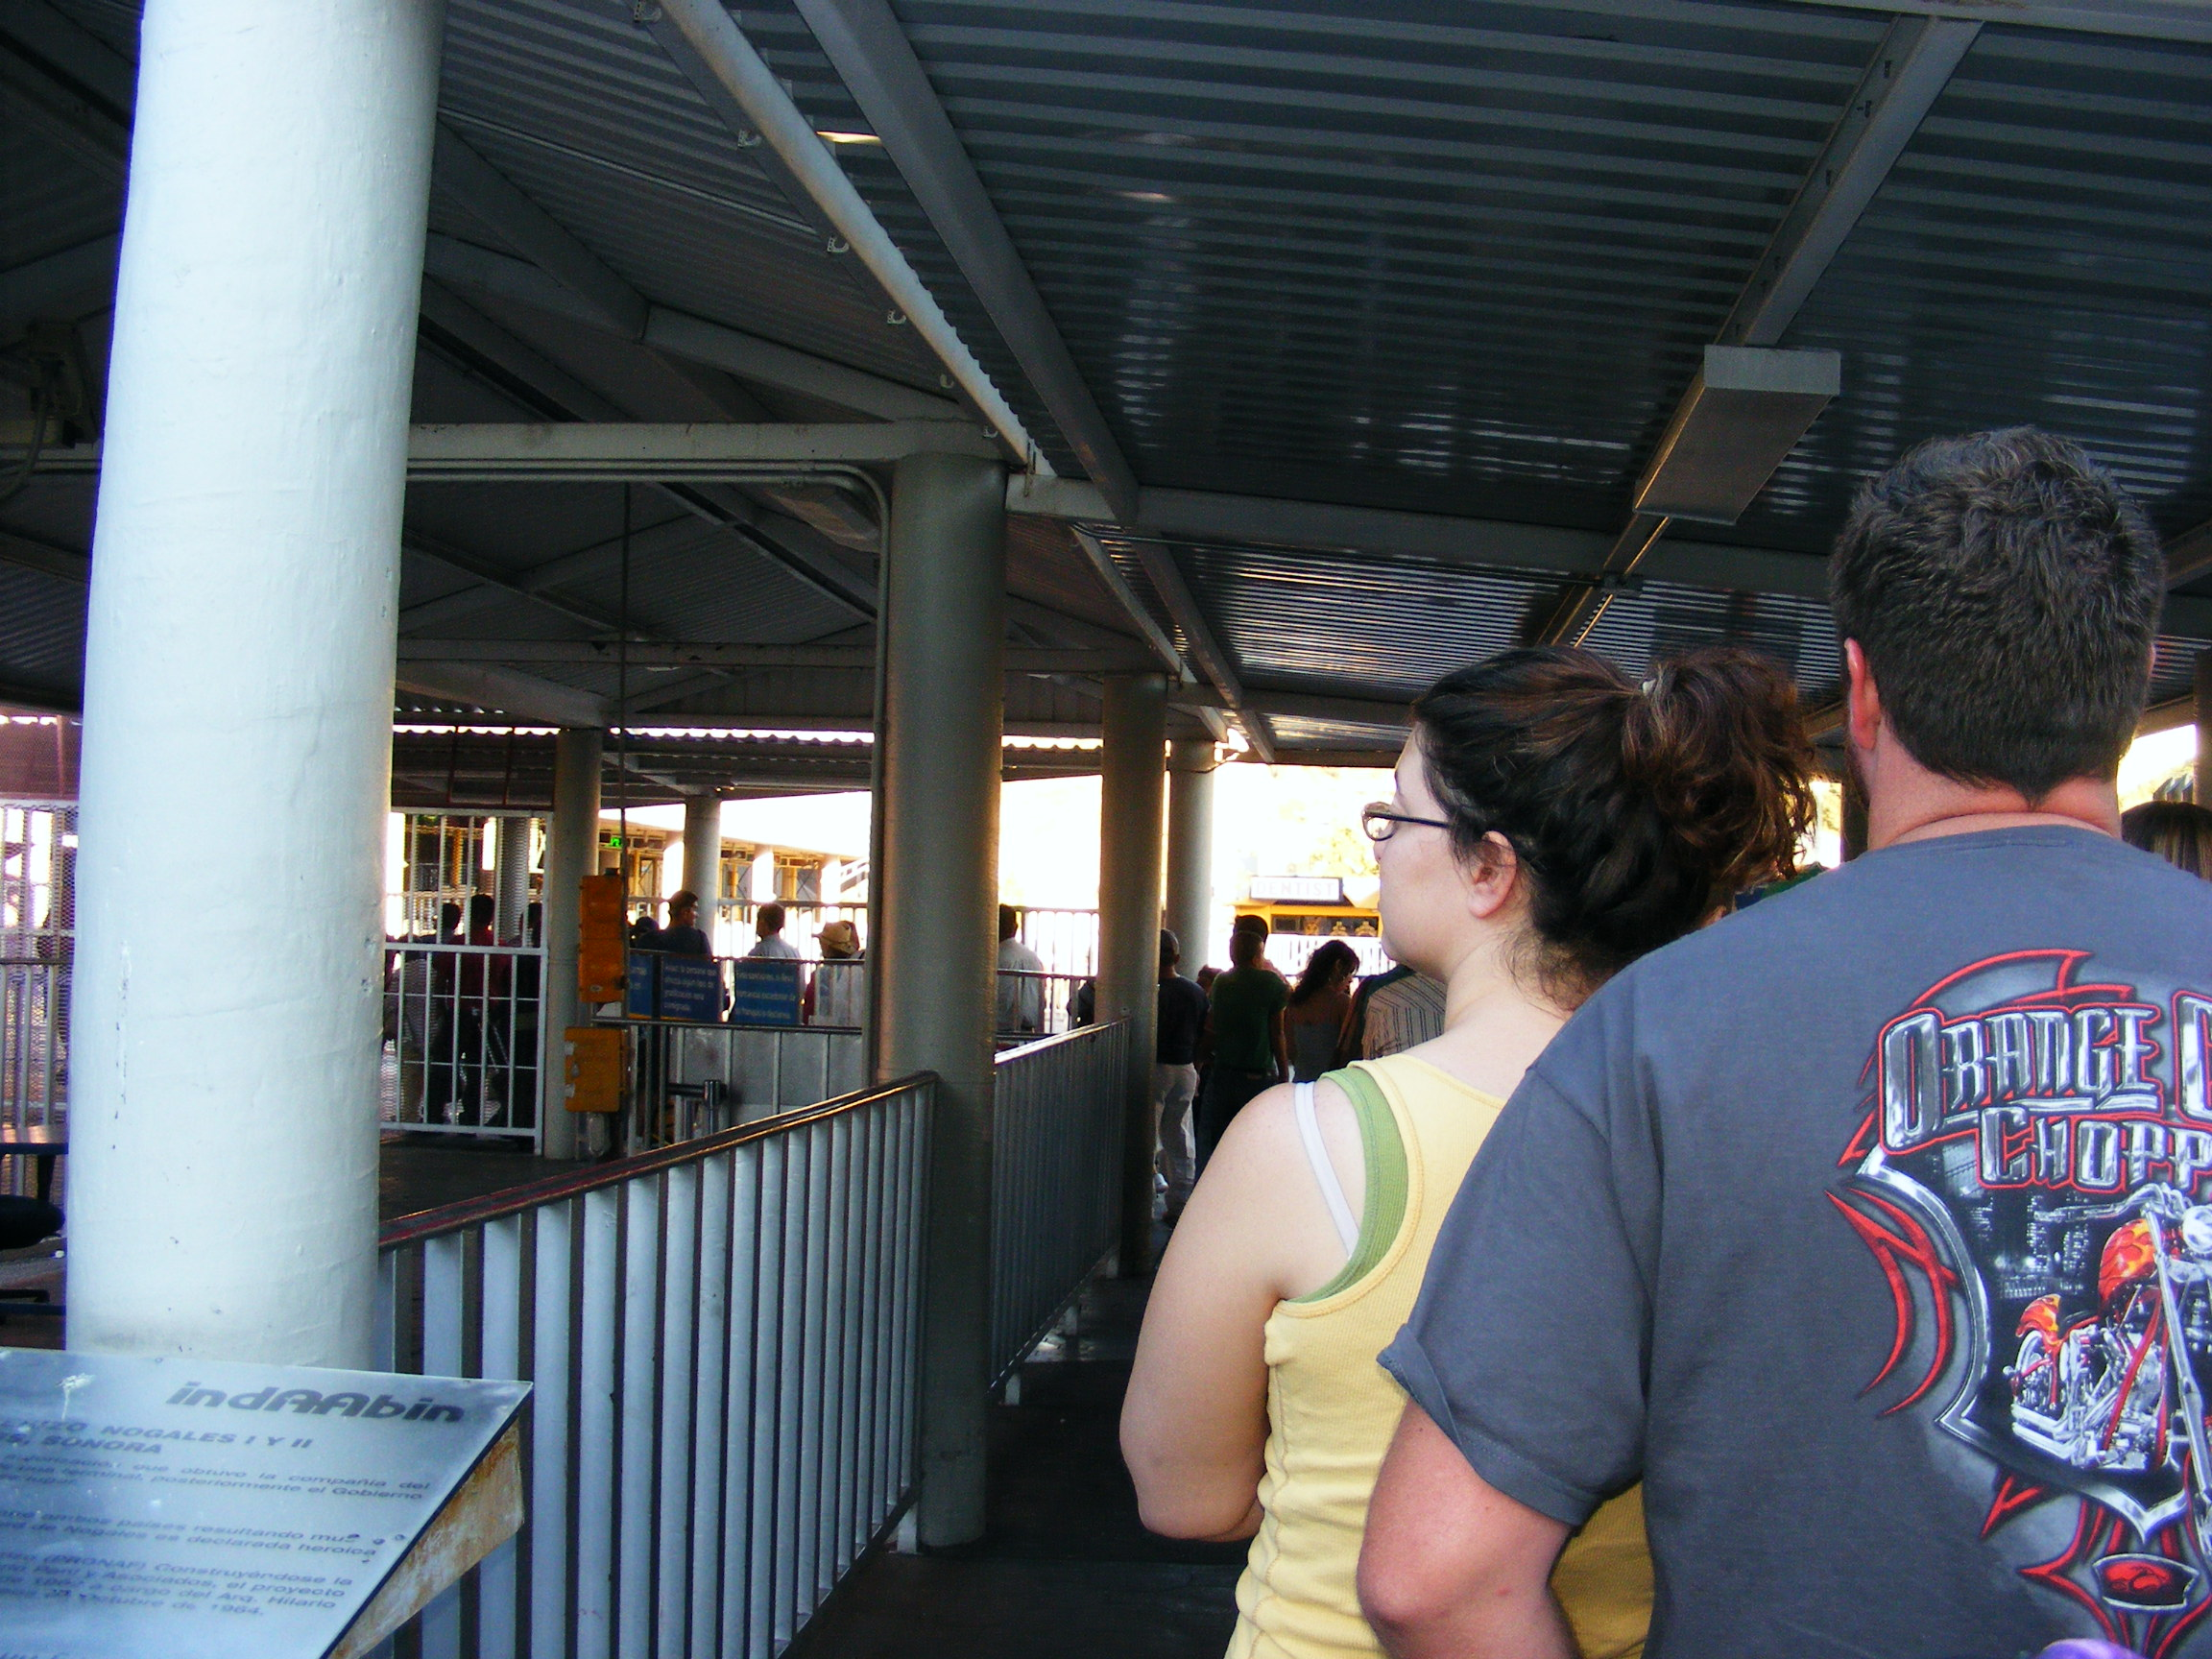

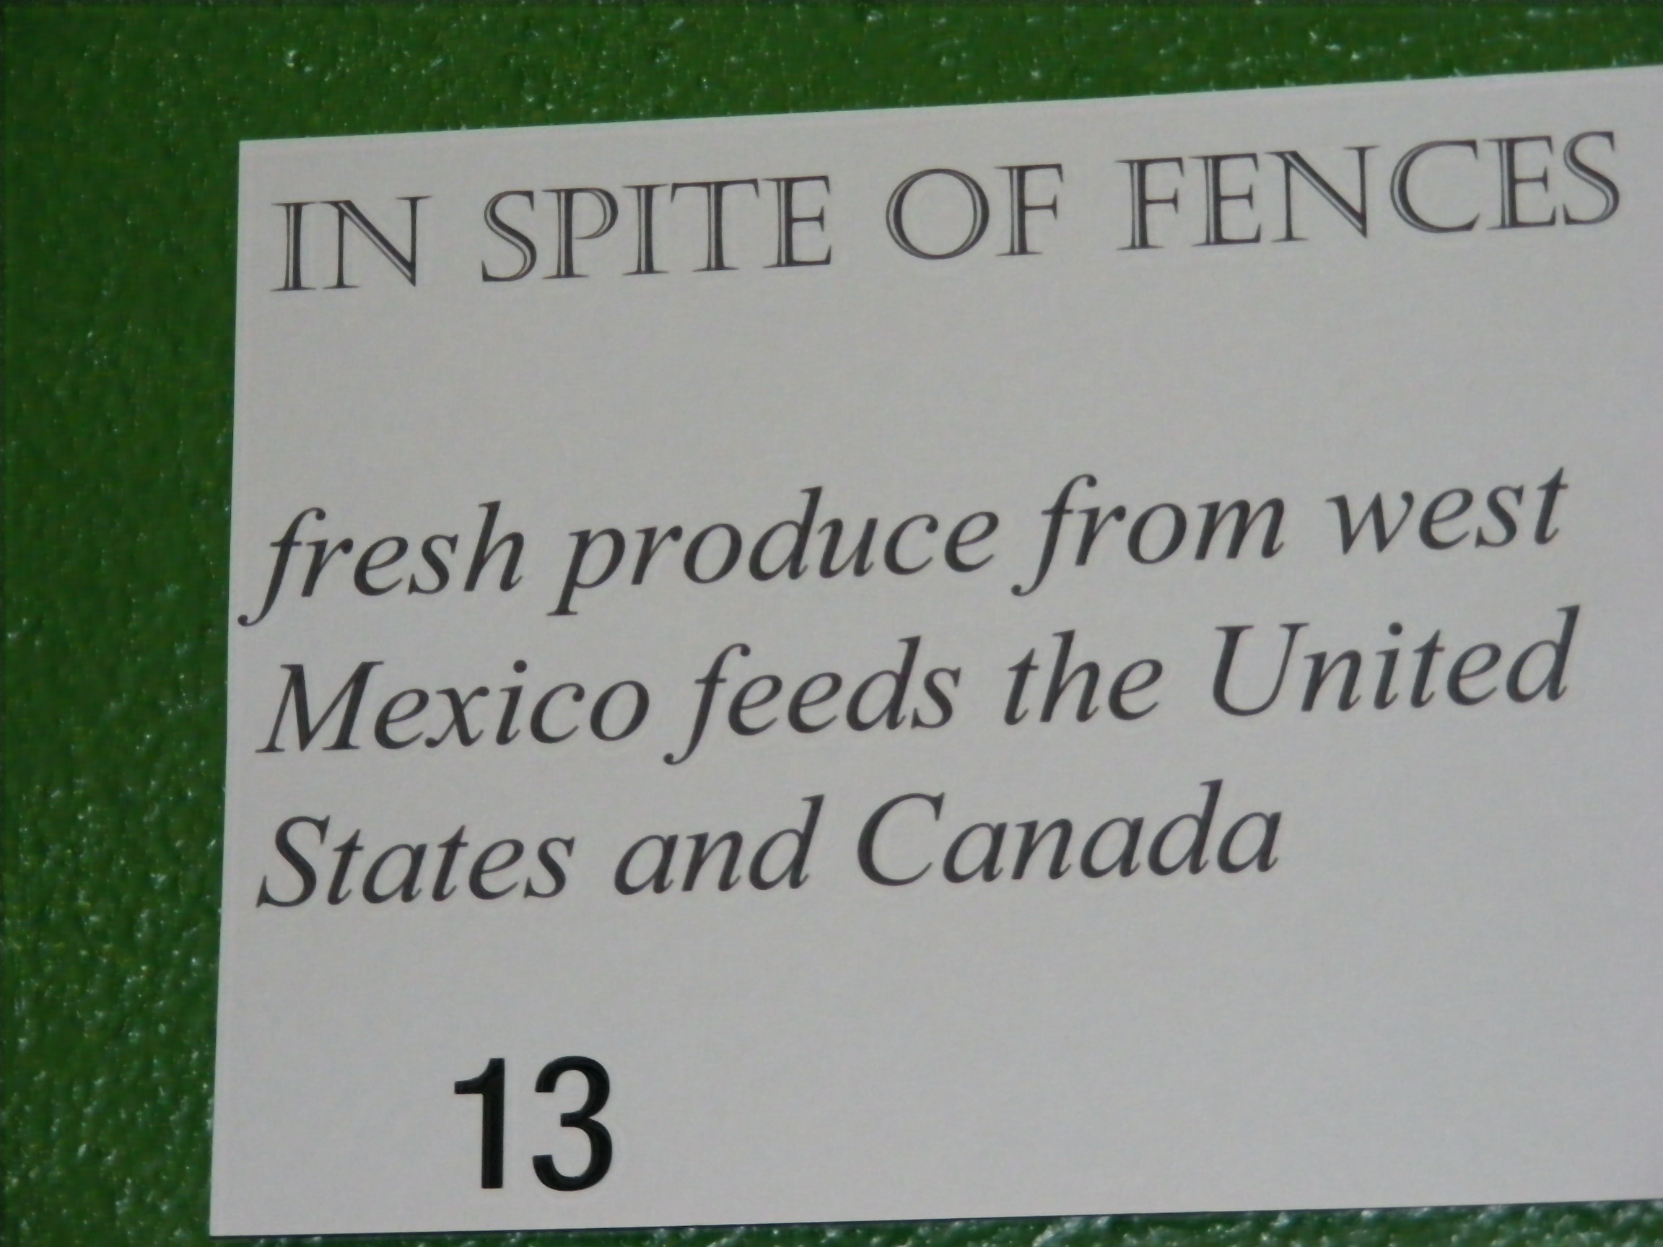

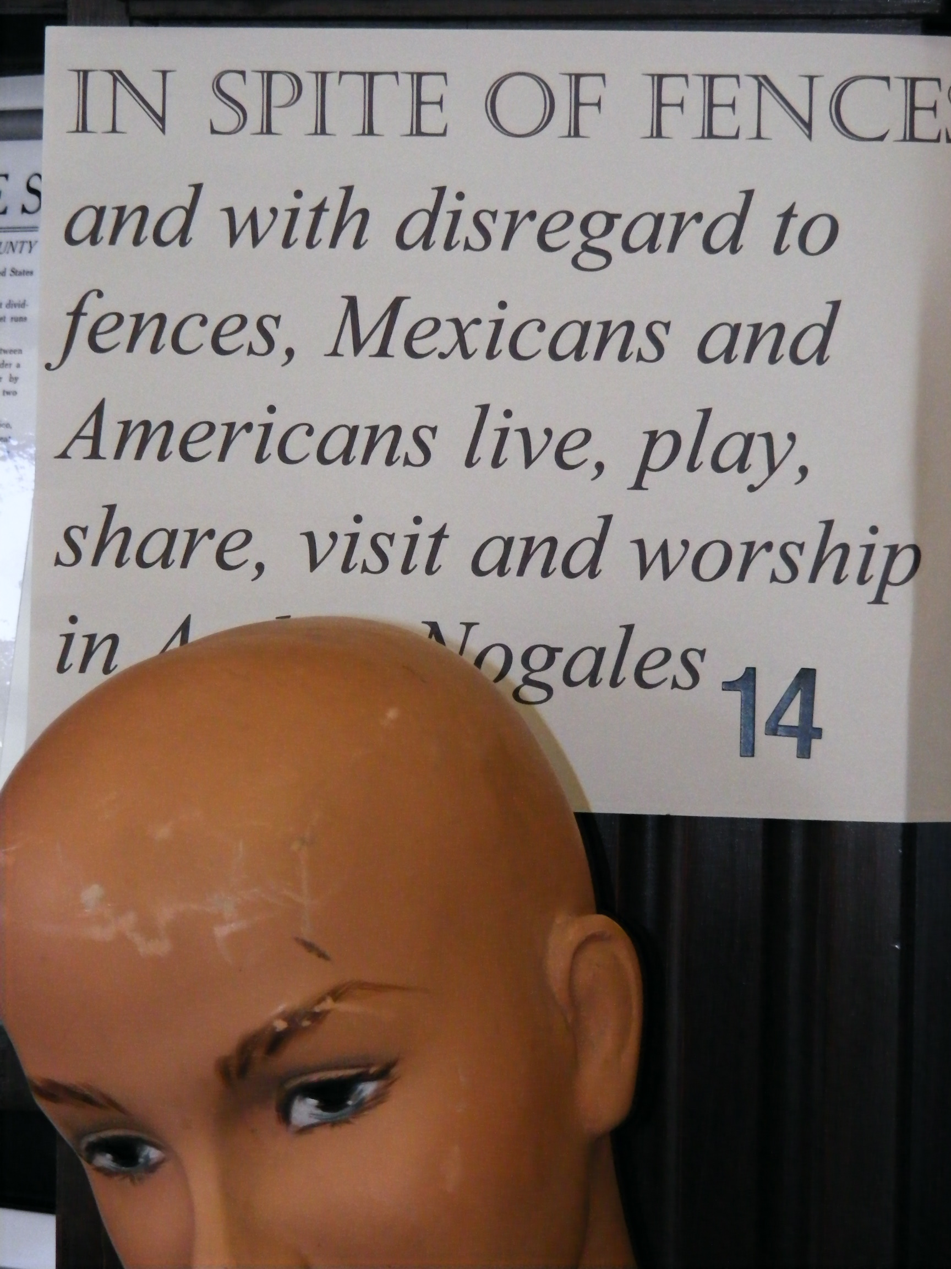

Governments

In what ways are the border governments similar and different and how is shared public policy determined or not?

Similarities
- Separation of Powers and Checks and Balances
- Federalism
- Liberties (2nd Amendment?)
- Judicial Review (but no public trials)
- Rule of law ????
- Republicanism
- City governments
- Mayors of both cities work on public policy together frequently
- Governors often work on public policy issues together
- Presidents sometimes work on public policy issues together
Differences
- Proportional representation
- Fewer liberties
- No public trails
- Less checks and balances in reality
- Mayor or presidente municipal
- AZ gov sent national guard to the border

Former Mexican president Vicente Fox says racism holding up immigration accord in US

Fox refuses to sign new drug bill that drew U.S. criticism

Fox's Revolution
From the Washington Post

Fox talk defends democracy

Economics
What is the influence of the significant bi-national amount of trade, both legal and illegal, on the border culture, people and economy?

- NAFTA (North American Free Trade Agreement)
  - Affect truck brokers?
  - Maquiladoras
  - “Fabuloso effect”
  - Outsourcing
  - “Walmart and Foodcity and “Chinos”
  - Tacobell in Mexico

- Illegal Trade
  - Drug trade
  - Sex trade
  - Polleros

Immigration/Migration

Mexican president on immigration
ABCNEWS.com video via Yahoo! News - Tue, Oct 09, 2007

